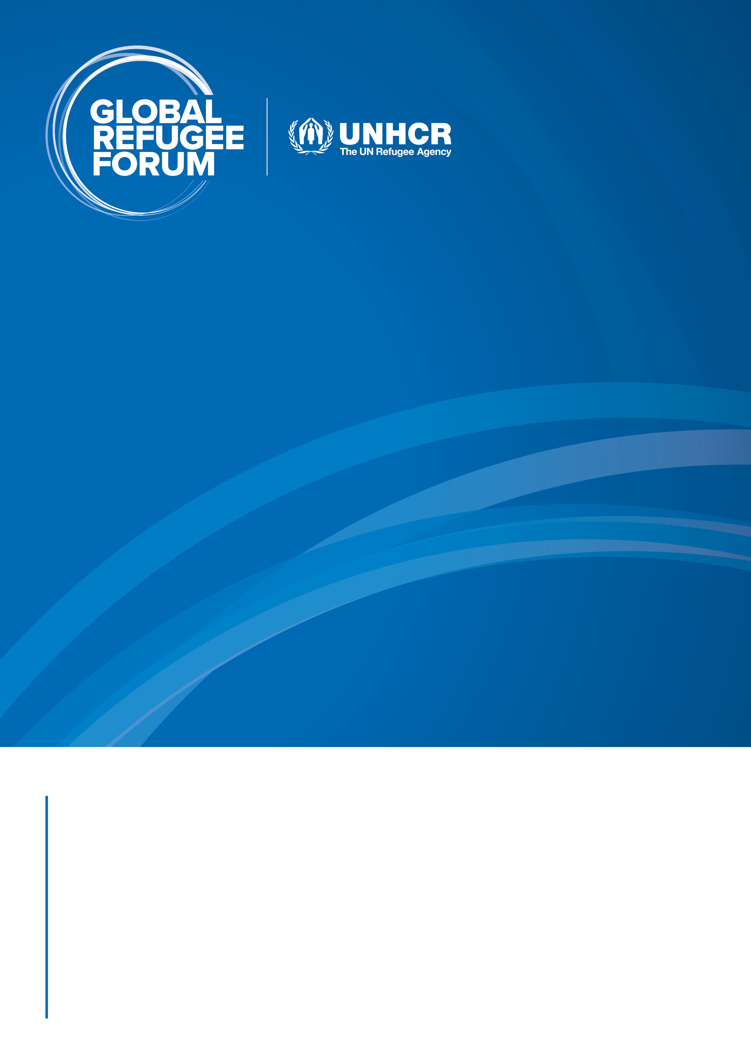

**REPORT OF THE**

PARALLEL HIGH-LEVEL EVENT

**Solutions In the Context of Forced Displacement Related to the Central African Republic Crisis**

15 DECEMBER 2023, (CET) | GENEVA

**Objectives of the meeting**

* Additional, multi-year, innovative and quality financing for humanitarian, development, and peace cooperation to advance solutions for the CAR situation.
* New financial, technical, and material support for host country policies, services and systems that advance inclusion;
* New job opportunities and access to financial products and services to advance economic inclusion;
* Strengthened financial and political support for voluntary sustainable return and reintegration, including access to services.

1. **Executive summary**

The event was attended by high-level representation of ministers and ambassadors the seven signatory states of the Yaoundé Declaration, as well as humanitarian actors and essential developments involved in the search for sustainable solutions for the Central African Republic, as well as an edifying plea from a Central African refugee. The Prime Minister and Head of Government of the Central African Republic has pledged the support of the from the Government of CAR to the platform. The Chairperson of the Steering Committee of the summarised the national action plans developed by the signatory States under three strategic pillars, as well as the resources required to implement them. For their Representatives from the seven countries highlighted strong political commitment and funding needs, international partners in the partners and presented, under the leadership of the African Development Bank, (AfDB), a joint statement in which they pledged to mobilize Additional resources to advance durable solutions for displaced people de force de la RCA.

The African Development Bank has also called on the international community to unite in this process towards sustainable solutions for all those affected by the crisis. This call has been well received by some development actors and the private sector present at the event. The Assistant High Commissioner for Operations closed the event by highlighting the real opportunity that the plans represent national and regional strategies to address one of the situations of forced displacement in the region, supporting peace, development and reconciliation initiatives.

1. **Key Outcomes**

The Prime Minister of the Central African Republic has pledged, on behalf of his country, to work closely with the Central African Republic's partners to ensure that all members of this group are supported in their mutual efforts.

The governments that signed the Yaoundé Declaration committed themselves to inclusiveness and peace linked to the concrete action plans they developed at the following the launch of the Solutions Support Platform for CAR. The total amount required to implement these plans is estimated at US$ 194 million. That includes access to rights for 50% of the population between 2024 and 2027, the construction and improvement of social services in the first access to employment opportunities, and improvement of the return environment nearly 300,000 refugees between 2024 and 2027.

The Special Representative of the Secretary-General (SRSG) of MINUSCA assured to continued and renewed support from United Nations systems to enable the the Government of the Central African Republic and the States Parties to the Yaoundé Declaration of Successfully implement recommendations and action points included in national plans.

The Supporting Partners Group, led by the African Development Bank, Development Authority, committed to actively support the implementation of the action plans and mobilize the necessary resources for their implementation.

The European Commission, through the Directorate-General for International Partnerships (INTPA), a member of the Supporting Partners Group, reiterated its Support for the platform through a commitment materialized by a contribution of 2 million of Euros to its secretariat. This contribution granted in 2022 covers the period of 2023 to 2024.

The Executive Director of the Africa II Group on the Board of Directors of the World Bank Abdul Salam Bello calls on the World Bank Group to fully engage with the group of supporting partners and increase its contribution.

The Amahoro Coalition, a member of the Supporting Partners Group, has Committed to helping mobilize the private sector to participate in inclusion displaced persons in CAR, to raise awareness of the potential of the refugee entrepreneurs, and mobilize donors and the private sector to secure funding for refugee-owned businesses.

Chad plans to allocate 300,000 hectares for refugee agricultural projects over the next three years.

The Republic of Congo is working to support the inclusion of refugees and refugees, asylum-seekers in basic social services, education and health.

UNDP reaffirmed its commitment to scaling up its own development actions in the context of forced displacement.

1. **Main Declarations**

Representatives of the seven signatory governments urged donors to provide more funds to achieve targets set for people forcibly displaced from CAR.

The Central African Prime Minister recalled that "without peace, there will be no return".

H.E. the Ambassador, Permanent Representative of the Republic of Chad to the United Nations Office at Geneva, has made a stirring appeal for peace as the only a definitive solution to the situation of the refugees and their allow them to return home safely. He urged the UN to bring peace between countries at war.

Mr. Gédéon Panté, a refugee from the Central African Republic, suggested that a Meaningful participation of IDPs and refugees in the platform would be highly desirable for the proper functioning of these solutions.

1. **Interventions**

**PART 1: Opening Segment**

* ***Mr. Mamady Souare,*** *Keynote speaker for Core Group, and Resident Representative COCF, African Development Bank*

The event will provide an opportunity to take stock of the solutions and best practices in line with the framework of the Solutions Support Platform that was officially launched by the Chief Executive Officer The Central African State, H.E. Professor Faustin-Archange TOUADERA. The Prime Minister of the RCA, Félix Moloua, is present for a joint animation.

* ***Mr. Félix Moloua,*** *Keynote speaker for States, H.E Prime Minister of Central African Republic*

Signatory States are called upon to support the implementation of the regional roadmap of the Bangui meeting. The Central African government is determined to work closely together with its partners to achieve a consistent effort and to ensure that all members of this group can be supported in their mutual efforts to find solutions to the problem. the crisis of forced displacement, and to support national strategies for solutions. The protection and respect for the rights of refugees and displaced persons will be at the heart of the commitment of all participants. The involvement of Core Group is welcomed, and the invitation is extended to the international community and partners to support initiative, by joining the Supporting Partners Group team. This event is an essential step towards making real change in the forced displacement crisis in RCA.

**Video projection of success stories**

**PART 2: Presentations Segment**

* ***Mr. Mohamed Ag Ayoya,*** *Speaker, Deputy Special Representative of the Secretary General, Resident and Humanitarian Coordinator at the MINUSCA*

The integrated approach of the peacekeeping mission and the United Nations system is This is an asset for the implementation of the Central African Platform to Support Solutions. The promoting an inclusive approach through the active engagement of civil society, local communities, displaced persons, refugees and returnees is a step towards essential to foster dialogue, participation and inclusiveness in processes Decision. Regional cooperation and collaboration among the signatory States of the Yaoundé Declaration should be encouraged to address cross-border challenges and support the platform.

The humanitarian situation in CAR is still fragile and is likely to reverse if the current trend continues. the low and slow funding for the 2023 humanitarian appeal continues. The United Nations system is providing renewed and ongoing support to enable the Government of the Central African Republic, as well as the States Parties to the Yaoundé Declaration to implement the successfully implements the recommendations made and the actions included in the national plans.

The international community is called upon to intensify its support for implementation of national action plans, which will strengthen the protection environment, socio-economic inclusion, contribute to the peace and national reconciliation process, and create conditions conducive to the return or reintegration of those affected by the Central African crisis. The Nexus must be implemented to provide an operational framework for effective and decentralised coordination and to cement the internal coherence and sustainability of the United Nations actions on the ground.

* ***Mr. Stephan Maurer,*** *Speaker, Geneva Representative of Danish Refugee Council*

Solutions for refugees are made possible thanks to four-year funding from INTPA, which enabled a consortium of four international NGOs (DRC-NRC-CARE-ACF) to implement the SOLID project (Sustainable Solutions and Initiatives). It aims to respond to the 150,000 people in Cameroon and the Central African Republic, 48 per cent of whom are women and 46 per cent refugees. Among the specificities of this project, we can mention the Nexus approach Programming and Graduation, its essential cross-border approach to reintegration refugees, the multi-year approach for a deeper impact because it avoids the discontinuities in strategy and implementation and allows for strong collaboration between specialized partners. It is therefore possible to provide what vulnerable people have needs, regardless of the category, status or location of populations with NGOs are working to help people out of extreme poverty.

* ***Mr. Gédéon Tanguy Just Panté,*** *Speaker, Refugee from Central African Republic*

It is essential to encourage and support countries of asylum to provide a legal framework for work adapted to the realities of refugees. This creates professional opportunities and thus promote financial independence. Access to socio-professional adapted to the specific needs of unskilled and less-educated refugees is also essential. Significant participation by displaced persons and refugees in the in the solutions support platform would be highly desirable for the smooth operation of these solutions, as well as the creation of an environment conducive to autonomy. All internally and externally displaced persons (IDPs) are called upon to show resilience and dynamism. Vibrant appeal to the international community international community not to forget the Central African crisis and to work for lasting solutions to build a better future for all.

**PART 3: National solutions segment**

* ***Ms. Virginie Baikoua,*** *Moderator, H.E. Minister of Humanitarian Action, Solidarity and National Reconciliation of CAR*

Summarize of the national action plans developed by signatory States of the Yaoundé Declaration:

The first strategic pillar aims at promoting and strengthening the institutions in charge of the protection of refugees and internally displaced. This encompasses the legal framework but also aims at facilitating the access to rights for 50% of the concerned population between 2024 to 2027. This is also about providing tools and services to enable refugees to have access to their rights and also to implement legal instruments and their legal framework. This includes all the rights to housing, accommodation, education. The cost of this pillar is about $24 million.

The second strategic pillar, which is to strengthen resilience and empowerment for displaced populations, waiting for long-term solutions. This encompasses the construction and improvement of social services in the arrival areas. It’s also about access to job opportunities, including in agriculture, but also promoting professional training, microfinancing, creating opportunities for displaced populations and the host communities so they can thrive and have access to national markets. The cost of this pillar is about USD 94 million.

The third strategic pillar is dedicated to the support of a favourable environment for long-term returns and reintegration of the displaced populations from CAR. This encompasses different initiatives and programmes to improve the environment for return of almost 300,000 refugees between 2024 and 2027. The cost of this pillar is about USD 76 million. The total cost of national action plans is USD 194 million, Sudan excepted.

**PART 4: Interventions from the floor segment**

* ***H.E. Lejeune Mbella Mbella,*** *Minister of External Relations of Cameroon*

Cameroon expresses its solidarity with the Central African platform and reiterates its country's efforts to implement the recommendations of the Yaoundé Declaration. Presentation of the eight priorities (protection, social and economic inclusion of refugees, empowerment of refugees, access to basic social services, long-term sustainable return of refugees, among others) proposed in Cameroon's new plan for a total of US$ 13 million. Intention to organize regular transnational meetings between Cameroon and the CAR on these and all parties wishing to participate.

* ***H.E. Irène Marie Cécile Mboukou,*** *Minister of Social Affairs, Solidarity and Humanitarian Action of the Republic of Congo*

The Republic of Congo, which currently shelters some 33,000 Central African refugees and asylum seekers, is strongly committed to finding solutions for their better care. Inclusion and empowerment initiatives for refugees and asylum seekers, notably through the implementation of social projects like Lisungui and the national social nets program, have since been the materialization of this commitment for the benefit of all refugees living in Congo and this, without any discrimination compared to local population. However, the numerous challenges can only be met in a spirit of solidarity and pooling of efforts by all those gathered for this high-level meeting.

* ***Hon. Angelina Jany Teny,*** *Minister of Interior of South Sudan*

Presentation of the two main strategies already implemented by his government: openness to refugees, access to schools for their children, access to identity cards and bank accounts. For this platform and these initiatives to continue strategic partners to continue to support these activities, not only for the return of those who are in the Republic of South Sudan or who choose to return, but also for those who would continue to earn a living there. However, host communities face a severe lack of resources. The Governments and donors are urged to work together to achieve tangible objectives for refugees and to secure more funding.

* ***H.E Jean-Claude Molipe Mandongo,*** *Vice Minister of Interior of Interior, Security and Customary Affairs of DRC*

Efforts of DRC to nominate three regional experts for setting up a national, technical committee and elaborate a national action plan for solutions. This plan will aim to strengthen refugees’ protection and ensure that assistance can be effectively rolled out. DRC is also supporting voluntary return and socioeconomic inclusion. Those that cannot yet return to their country of origin can be integrated on a local level in DRC. Challenges are still numerous and called for the mobilization of the international community for more resources to support the still fragile States of the central African region.

* ***H.E. Dr. Jean-Pierre Baptiste,***Ambassador, Permanent Representative of the Republic of Chad to the UNOG

The living conditions of many refugees are very difficult. Nevertheless, Chad is a country that applies the legal instruments that have been put in place to focus protection of refugee populations. Working together on key priorities to ensure that measures are taken to improve the situation of refugees is important, as is the need to review documents, identity cards and biometric passports for refugees, productive activities in terms of agriculture livestock farming. Over the next three years, Chad plans to allocate three hundred thousand hectares for this purpose. Calling on partners from financial institutions to reiterate and strengthen their agreements in a spirit of partnership and shared responsibility, to ensure that Chad has the necessary finances to support refugees and ensure their to make their socio-economic integration a reality.

* ***H.E. Ali Hassan Hamid Hassan HAMID,*** Ambassador Permanent Representative of Sudan to the UNOG

before the war,BSudan hosted thousands of refugees. They were integrated socially and culturally within communities. They were treated just as any other Sudanese citizen. And they were given opportunities to integrate schools and colleges in Sudan. Unfortunately, and due to the political situation now, they were forced to seek refuge once again, either internally or to go across borders to their home countries. Despite the current situation, his country supports durable solutions for refugees and plead to identify holistic solutions tackling the root causes of forced displacements.

* ***Mr. Vittorio Capici​,*** Program Manager, European Commission​

At the end of October, INPTA's General Management was represented in Bangui to take part in the launch of the platform, the first step in the fight for the situation of Central African after the signing of the Yaoundé Declaration in April 2022. The EU shared efforts of the Central African government, the platform, signatory governments signatory governments, the UNHCR and partners in the Supporting Partners Group, to find sustainable solutions to these protracted displacement crises. Support for the platform by the European Union with funding of 2 million Euros for its secretariat. This reflects the EU's commitment to helping the Central African population living within the country the country and throughout the region, to return to their places of origin, and to do so peacefully, voluntarily and with dignity.

* ***Mr. Abdoul Salam Bello****​,* Executive Director of the Africa Group II at the World Bank Group Board of Directors

Commitment on behalf of the group of supporting partners led by the African Development Bank actively support the implementation of national and regional strategic action plans and to mobilize the necessary resources for their implementation. The platform is fully aligned with the objectives of the Global Compact on Refugees by promoting and facilitating comprehensive approaches to addressing forced displacement, protection solutions, while emphasizing the importance of coordination and collaboration between all all stakeholders in the humanitarian, development, peace and private sector. Calling on the international community to join forces in this drive towards lasting solutions for all those affected by the crisis in CAR.

* ***Mr. Isaac Kwaku Fokuo​,*** Founder of The Amahoro Coalition

Commitment to mobilize the private sector to participate to economic inclusion of displaced people of CAR and to raise awareness of the economic potential of refugee entrepreneurs. Engagement of donors and private sector to secure funding for refugee owned businesses. These positive outcomes will include and provide a significant improvement in the economic situation of refugees and will contribute to the self-sufficiency and less dependency on humanitarian aid. Call upon all stakeholders to join hands in this very important endeavor and recalled that the private sector has the opportunity to be a force for good.

* **Catherine Osborn​,** Policy Adviser - Forced Displacement, UNDP Crisis Bureau

UNDP welcomed the Yaoundé Declaration as it's rooted in the leadership and ownership of local stakeholders as well as local and regional authorities. At this year’s GRF, a new HDP multistakeholder pledge co-led by the Government of Japan was launched precisely to support government efforts to ensure complementary between the HD & P. And UNDP looks forward to deepening its partnerships with the Government of CAR but also with surrounding countries. UNDP also announced that, with the support of the African Development Bank, a new cross-border project between CAR and Chad precisely to work on stabilization. This is evidence of UNDP’s commitment to stepped-up development action in forced displacement. This is at the corner stone of UNDP’s pledge at this year's GRF where it will expand its support to host countries and those welcoming returnees to ease pressure and protect development gains.

**PART 5: Joint Declaration by AfDB on behalf of the Core Group**

* ***Mr. Mamady Souare,*** Resident Representative COCF, African Development Bank

Commitment on behalf of the group of supporting partners led by the African Development Bank actively support the implementation of national and regional strategic action plans and to mobilize the necessary resources for their implementation. The platform is fully aligned with the objectives of the Global Compact on Refugees by promoting and facilitating comprehensive approaches to addressing forced displacement, protection solutions, while emphasizing the importance of coordination and collaboration between all stakeholders in the humanitarian, development, peace and private sectors. private sector. Calling on the international community to join forces in this drive towards lasting solutions for all those affected by the crisis in CAR.

**PART 6: Closing segment**

* ***Mr. Raouf Mazou,*** *Assistant High-Commissioner to Operations*

Closing the event by highlighting the real opportunity that national and regional to resolve one of the region's most protracted situations of forced displacement in the region, supporting initiatives for peace, development, security and national security and national reconciliation initiatives in the Central African Republic. The platform plays a key role to ensure synergies for the successful reintegration and return of refugees to their countries of origin. A call for collective responsibility to ensure that all those who have had to flee can return home, get on with their lives and never have to flee again.